Volumetric Bubble Display

Yoshio Hayasaki & Kota Kumagai
Center for Optical Research and Education (CORE), Utsunomiya University
7-1-2 Yoto, Utsunomiya 321-8585, Japan
Tel.:+81-28-689-7114, E-mail: hayasaki@cc.utsunomiya-u.ac.jp

OCIS codes: (110.0110) Imaging systems; (300.0300) Spectroscopy; (110.1758) Computational imaging

Much attention has been paid to the development of three-dimensional volumetric displays in fields of optics and computer graphics, and it is a dream of we display researchers. They can render 3D graphics in real 3D space, and therefore, a volume image can be observed from any surrounding viewpoints without the user having to wear any special devices or experience physiological discomfort [1]. These optically-accessed volumetric displays have a wide viewing angle because they require no physical connection between the light source and the display volume. Therefore, reconfigurable and parallel connections are easily achieved, resulting in good accessibility and high drawing speed to the voxels. We developed three kind of volumetric displays with laser-excited florescence voxels[2], laser-produced plasma voxels[3], and laser-produced micorbubble voxels[4]. In this presentataion, we focus a volumetric display using light-scattering voxels formed of microbubbles induced by focused femtosecond laser pulses in high-viscosity liquid. This display is called as a volumetric bubble display.
Volumetric bubble display consisted of an amplified femtosecond laser source (Micra and Legend Elite Duo, Coherent), a 3D beam scanner composed of a 2D galvanometer mirror (GM-1010, Canon) and varifocal lens (EL-10-30- Ci, Optotune), a liquid-crystal on silicon SLM (LCOS-SLM; X10468-02, Hamamatsu Photonics) for holographic laser drawing, and glycerin in a glass cell. The femtosecond laser had a center wavelength of 800 nm, a repetition frequency of 1 kHz, and a pulse duration of <100 fs. The galvanometer scanner changed the focus position in the horizontal direction. A varifocal lens controlled the focus position in the axial direction. The 3D focal position was changed by these devices to render the 3D graphics. The LCOS-SLM displayed Fourier CGHs at a frame rate of 10 Hz. The Fourier CGHs were optimized by the optimal rotating angle method to generate parallel beams. The screen was glycerin sealed in a glass cell with dimensions 10 mm × 10 mm × 100 mm.
Figure 1(a) shows 3D bubble graphics viewed from different observation directions. These graphics were rendered by scanning 100 2D outlines of cross-sectional images from ear to foot, and were illuminated by the halogen lamp. The irradiation energy was 4.3 μJ. The volumetric graphics was successfully rendered by using femtosecond laser-induced microbubbles. Figure 1(b) shows the bubble graphics illuminated by light of different colors. The illumination light was emitted by a high-power full-color LED capable of outputting light of different colors. The center wavelengths were 624 nm (red), 525 nm (green), and 470 nm (blue). The irradiation pulse energy was 5.4 μJ. Although these results are monochrome graphics with different colors, it will be easy to form full-color bubble graphics by changing the color of the illumination light.

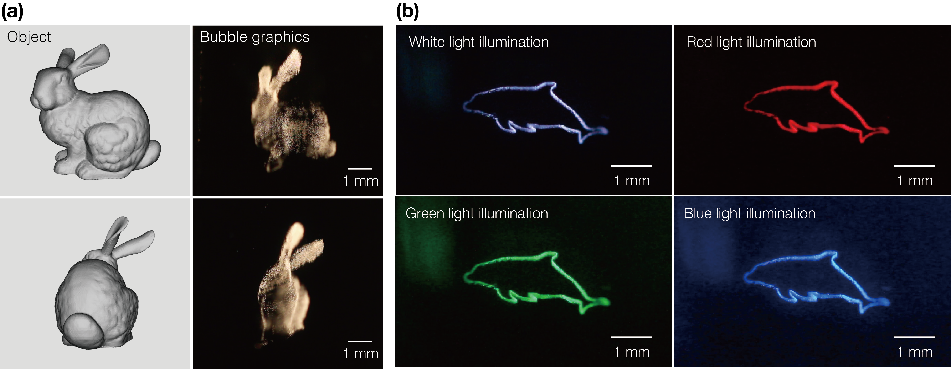
Fig. 1 (a) Volumetric graphics of “Stanford bunny” rendered by femtosecond laser-induced microbubbles. (b) 2D bubble graphics of “Dolphin” with illumination light having different colors.

References
- B. G. Blundell and A. J. Schwarz, IEEE Trans. Vis. Comput. Graph. 8, 66–75 (2002).
- K. Kumagai, D. Suzuki, S. Hasegawa and Y. Hayasaki, Opt. Lett., 40, 3356–3359 (2015).
- Y. Ochiai, K. Kumagai, T. Hoshi, J. Rekimoto, S. Hasegawa, Y. Hayasaki, ACM Trans. Graph. 35, 1–14 (2016).
- K. Kumagai, S. Hasegawa and Y. Hayasaki, Optica 40, 298–302 (2017).

